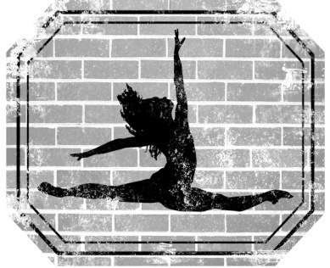

Registration and Tuition
Studio Rates for Fall/Spring 2018- 2019

Annual registration fee and the first month’s tuition must be paid upon registration.
Annual Registration Fee = $25.00/student or $40.00/family
Tuition Due = 1st class of each month
Returned Checks = $30.00 fee

Monthly Payment Option:
Pay standard monthly rate
Registration/First month’s tuition due upon enrollment
Account must be paid in FULL to participate in the Spring Recital
$10.00 monthly discount on tuition for each additional child enrolled

Yearly Payment Option:
Pay entire 10 month session at one time and receive a 5% discount on tuition
Not included in the yearly payment option is registration, holiday costume fee, spring costume fee and spring recital fee, etc.
This offer is available on until October 1st
Account must be paid in FULL to participate in the Spring Recital

Additional Fees:
Holiday Costumes = $70.00/costume
Spring Costumes = $80.00/costume or $150.00/ 2 costumes
Spring Recital Fee = $50/student or $90/family

Thank you for choosing TDWS as your dance studio!
Phone: 281-732-7196 Email: ebburttschell@yahoo.com

