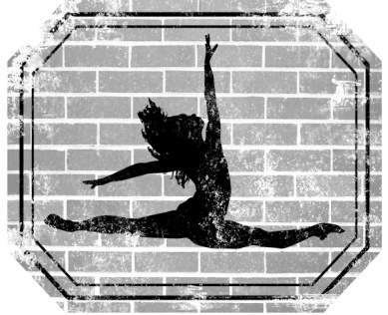

TDWS Class Attire

Girls must wear their hair fastened securely in a bun or ponytail on the back of the head for all classes. Boy’s hair must be neatly combed. Do not wear jewelry in class (earrings, bracelets, rings, necklaces, watches, etc.)

Preschool Ballet and Tap

Any Leotard, Tights, Skirt or Shorts, Pink Ballet Shoes and Black Tap Shoes

Ballet, Tap, & Jazz - Level 1 &2

Black Leotard, Pink Tights, Black Shorts or Skirt, Pink Ballet, Black Tap Shoes and/or Black Jazz Shoes

Drill Team Prep Level 1 and 2

Black Leotard, Black Shorts or Capri Pants and Black Jazz Shoes

Company

Black Leotard, Black Tights or Leggings, Required Shoes for class

Hip Hop

Any TDWS shirt, Black Capri Pants or Leggings, Dance Sneakers or Hip Hop Shoes

Lyrical

Black leotard, Black Shorts or Capri Pants and Nude Footies

Tumbling
Any Leotard, Shorts or Capris, Hair pulled out of face

