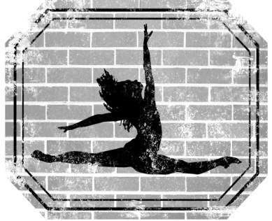

Studio Policies and Procedures
At TDWS we are please that you have entrusted us with your child. You can look forward to a wonderful year of learning, growing, and dance. The following policies are in place to enhance the lives of our students and their families through the art of dance. If you have any questions about our policies please contact Mrs. Erika.

STUDIO POLICIES:
- Parents are not allowed to sit in class without the permission from an instructor.
- No chewing gum is allowed anywhere in the studio.
- Dancers must use the restroom before class. Leaving during class time is discouraged.
- Students must wear a cover-up to and from dance class.
- Students must come to class in dress code.
- Students must have their dance attire and shoes labeled with their initials.
- Parents must supervise all accompanying siblings.
- Children cannot be left unattended.
- TDWS staff is not responsible for providing care to students before or after class. We understand that there could be extenuation circumstances that prevent you from coming on time. In that case please call or text the studio to inform us.
- You must inform TDWS of ANY health issues of your child.

CODE OF CONDUCT:
- Students and parents will dress and conduct themselves in an appropriate manner while at TDWS and at all performances, competitions, recitals and events in which TDWS is being represented.
- Proper respect for the staff and fellow students is expected of all students, parents/guardians and siblings.
- Attitudes that are disrespectful, uncooperative, or aggressive do not have a place at TDWS.
- Students will not speak negatively about one another or the instructors.
- Any parent/guardian or student who disrupts class or approaches a teacher, staff member, another student or parent with the intent to cause dissent or contravene the policies and procedures of TDWS will be dismissed immediately.
- Any inappropriate or slanderous remarks about TDWS or its staff members on any social media site will be cause for immediate dismissal from the studio.
- If you have a concern or grievance you must make an appointment with the studio director (Erika Burttschell), or you are welcome to send an email to discuss the issue.

COMMUNICATION:
- TDWS will send home reminders about events and also send out emails. Please make sure you give a current email address to stay updated on the latest news.

SNACKS AND DRINKS:
- Snacks and drinks are not allowed on the studio floor. Only water is allowed in class.

CLASSES:
- Any missed class may be made up in a similar level within two weeks of the missed class.
- Please check with your child’s instructor for their recommendations. No refund or deductions are made for missed classes.
- In the unlikely event a teacher/substitute teacher cannot be arranged, any cancelled classes will be rescheduled.
- Please do not let your child enter the dance studios until the teacher calls them in for class.

Thank you for choosing TDWS as your dance studio!

